Scheduling Exams
Step 1: Log into MinerAccess using your S&T username and password.
Step 2: Under Accommodations on the left menu, select Alternative Testing.
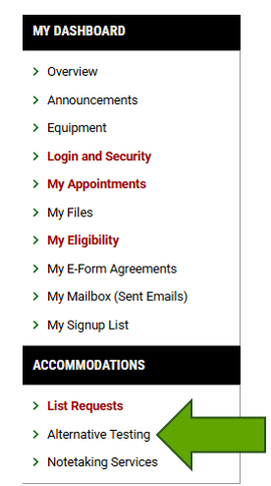
Step 3: Select Class
At the top, select the class using the drop-down list and click Schedule an Exam
- For classes with multiple sections - choose the main lecture section (Example: MATH 1214 select your lecture: 1A, 1B or 1C)
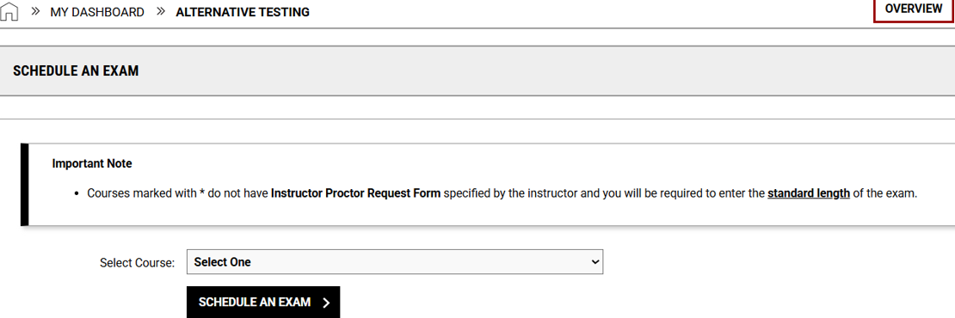
Step 4 : Complete Exam Details
In the Exam Request section:
- Use the drop-down list to select the exam type
- Type in the date of the exam and select the time you will begin the exam
- In the services requested section, select the accommodations you need for the exam
- If you have any notes for the testing center, you can information in the additional note
- Review Terms and Conditions
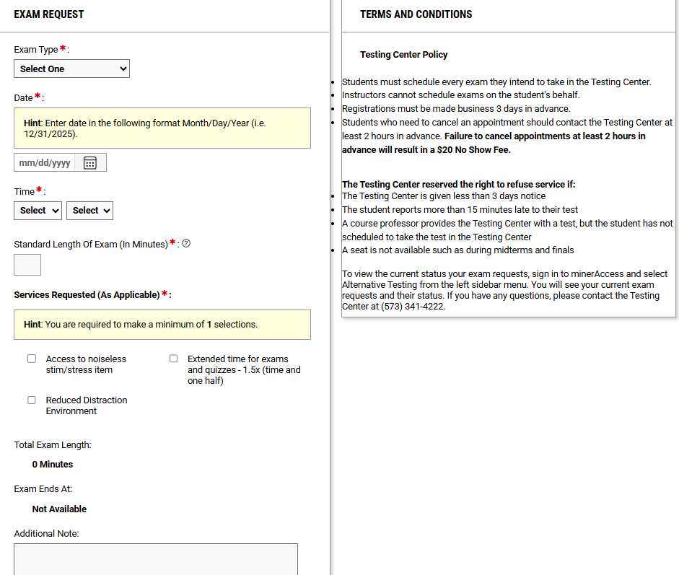

Step 5: Add Exam Request
Under Form Submission, select Add Exam Request
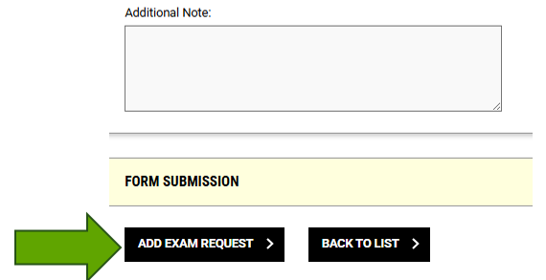

Success! You will receive an e-mail from S&T Testing Center when your exam request has been confirmed.

